INDIAN SCHOOL AL WADI AL KABIR
DEPARTMENT OF SOCIAL SCIENCE
MID TERM ASSESSMENT 2023-24
(ANSWER KEY)
CLASS: VII Max: Marks: 80
Date: 26/09/2023 Time: 2½ Hrs.
General Instructions: -
- Ensure that you have written your name and roll number correctly.
- This Question paper has three parts, Section A (History) B (Civics) and C (Geography).
- All questions are compulsory.
- Attach the Map along with your answer script.
- All the answers must be correctly numbered as in the question paper in the Answer sheet provided.
 | SECTION – A (HISTORY) 30 Marks
I | Multiple Choice Questions: - | 3 MARKS
1 | Name the language which gives more respect to the Brahmanas  Konkani (b) Sanskrit (c) Tamil (d) Arabic | 1 Mark
2 | What is the other name of the great lord of a ‘circle’ or region?  - Samantas (b) King ( c) Maha-mandaleshwara (d) Subordinates | 1 Mark
3 | Which of the following was the capital of Vijayanagara?  (a) Hampi (b) Ajmer (c) Surat (d) Thanjavur | 1 Mark
II | Match the following: - | 2 MARKS
4 | 1. Al-Idrisi a. Western Deccan | 1 Mark
5 | 2. Palas b. Arab geographer. | 1 Mark
 | c. Bengal
 | Ans. 1=b, 2=c
III | Answer in one or two sentences: - | 3 MARKS
6 | List any two of the technological changes associated with Mughal period.  Some notable technological changes associated with this period were:  (i) The use of Persian wheel in irrigation;  (ii) The use of spinning wheel in weaving;  (iii) The use of firearms in combat. | 1 Mark
7 | Who were the parties involved in the ‘Tripartite Struggle’?  The parties involved in the tripartite struggle were Gurjar-Pratihara, Rashtrakuta and Pala dynasties. | 1 Mark
8 | “The Crafts persons of Bidar were famous” Give reasons  The Craftspersons in Bidar was famous for their inlay work in copper and silver. | 1 Mark
IV | With reference to the given pictures, answer the following questions. | 6 MARKS
9 | 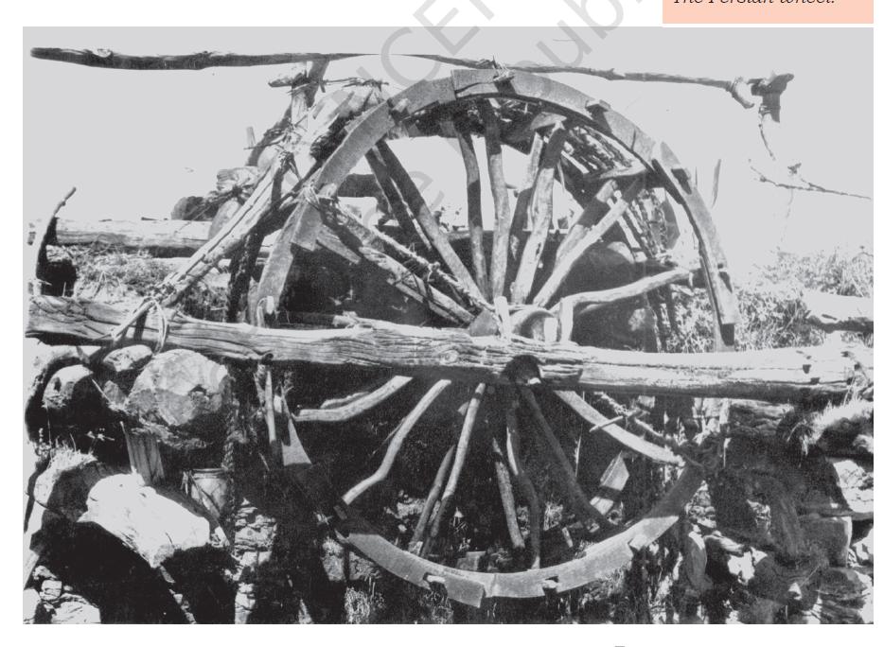  a. Identify the picture.  Ans. The Persian Wheel.  b. What was it used for?  Ans. It was used by the farmers in olden days to lift water / irrigation | 2 Marks
10 | 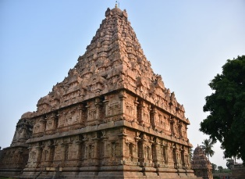  a. Identify the temple.  Gangaikondacholapuram  b. Who lived near the temples?  Priests, garland makers, cooks, sweepers, musicians, dancers. | 2 Marks
11 | 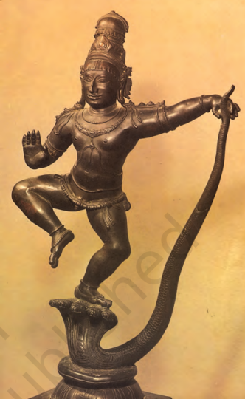  a. Identity the picture.  A bronze statue of Krishna subduing the serpent demon Kaliya.  b. What was the technique used by the Cholas for making bronze statues?  The lost wax technique was used for making Chola bronze statues. | 2 Marks
V | Answer the Following: - | 6 Marks
12 | Read the following paragraph and answer the following questions: -  One such ruler is Mahmud of Ghazni, Afghanistan. He raided the subcontinent 17 times (1000–1025) with a religious motive. His targets were wealthy temples, including that of Somnath, Gujarat. Much of the wealth Mahmud carried away was used to create a splendid capital city at Ghazni. Other kings who engaged in warfare included the Chahamanas, later known as the Chauhans, who ruled over the region around Delhi and Ajmer. They attempted to expand their control to the west and the east, where they were opposed by the Chalukyas of Gujarat and the Gahadavalas of western Uttar Pradesh. The Chahamana ruler was Prithviraja III (1168–1192), who defeated an Afghan ruler named Sultan Muhammad Ghori in 1191, but lost to him the very next year, in 1192.  A. What was the target of Mahmud of Ghazni?  The targets were wealthy temples, including that of Somnath, Gujarat.  B. What were Chahamanas known as?  Chahamanas were known as the Chauhans, who ruled over the region around Delhi and Ajmer.  C. Who was Prithviraja III? Who defeated him?  Prithviraj III (1168-1192) was a Chahamana ruler, later known as Chauhan. He was defeated by Muhammad Ghori. | 3 Marks
13 | Hampi is located in the Krishna-Tungabhadra basin, which formed the nucleus of the Vijayanagara Empire, founded in 1336. The magnificent ruins at Hampi reveal a well-fortified city. The buildings in the royal complex had splendid arches, domes and pillared halls with niches for holding sculptures. They also had well-planned orchards and pleasure gardens with sculptural motifs such as the lotus and corbels. Temples were the hub of cultural activities and devadasis (temple dancers) performed before the deity, royalty and masses in the many-pillared halls in the Virupaksha (a form of Shiva) temple.  A. On which river basin, Hampi is located?  Hampi is located in the Krishna-Tungabhadra basin.  B. What were the features of buildings in Hampi?  The buildings in the royal complex had splendid arches, domes and pillared halls with niches for holding sculptures.  C. Who were the ‘Devadasis’?  Devadasis were the temple dancers who performed in front of lord Shiva. | 3 Marks
VI | Answer in detail: - | 5 MARKS
14 | In what ways has the meaning of the term ‘Hindustan’ changed over the centuries. What sources do historians use for the study of a particular period in history?  The meaning of the term ‘Hindustan’ has changed over the centuries in the following manner:  - In the thirteenth century Minhaj-i-Siraj used the term ‘Hindustan’. He meant areas of Punjab, Haryana and the lands between Ganga and Yamuna. He used this term in a political sense that were a part of the dominions of the Delhi Sultanate. The term never included South India.  - In the sixteenth century poet Babur used the term ‘Hindustan’ to describe the geography, the fauna and the culture of the inhabitants of the subcontinent.  - In fourteenth-century poet Amir Khusrau used the term ‘Hind’ in the same sense as Babur did in the sixteenth century.  - ‘Hindustan’ did not carry the political and national meanings as the term ‘India’ does today.  - The historians use sources like coins, inscriptions, architectures, and textual records for the study of a specific period. | 5 Marks
VII | On the given outline map of India Identify and mark the following Kingdoms and Trade centres. | 5 MARKS
- Delhi (B) Surat (C) Nalanda (D) Hampi (E) Thanjavur

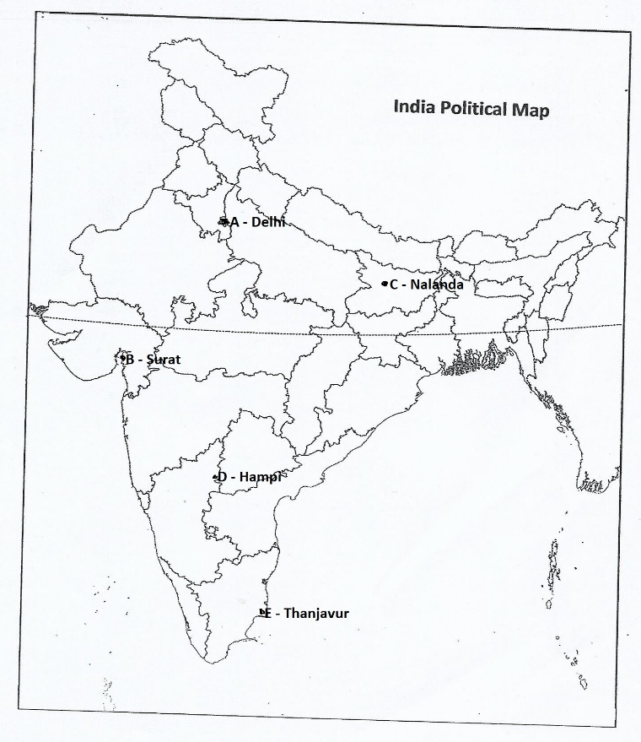

 | SECTION – B (CIVICS) 20 MARKS
VIII | Choose the correct answer: - | 3 MARKS
15 | Which of the following is NOT an element of equality?  (a)Justice (b) Religion v(c) Wealth (d) Health | 1 Mark
16 | Which one of the following is the healthiest country in South America?  a) USA b) Canada c) Brazil d) Costa Rica | 1 Mark
17 | Which one of the following is not a water-borne disease?  a) Diarrhea b) Cancer c) Hepatitis d) Worms | 1 Mark
IX | Fill in the blanks: - | 2 Marks
18 | When people are treated unequally, their is dignity violated. | 1 Mark
19 | The resources to run the public health services are obtained from taxes. | 1 Mark
X | Answer in one or two sentences: - | 3 MARKS
20 | What do you mean by ‘Disabilities Act’?  According to Disabilities Act, A person with disabilities have equal rights and the government should make possible their full participation in society. | 1 Mark
21 | Why are poor people more likely to fall ill?  Poor people are more likely to fall ill because they are not provided with the basic necessities like drinking water, adequate housing, clean surroundings, etc. | 1 Mark
22 | What are the two categories of healthcare services?  There are two broad categories of healthcare services.  1.Public health services.  2.Private health facilities. | 1 Mark
XI | Answer the following: - | 6 MARKS
23 | List the two ways in which the government has tried to implement the equality  that is guaranteed in the Constitution.  The two ways in which the government has tried to implement the equality that is guaranteed in the Constitution is  - First through laws and  - Second through government programmes or schemes to help disadvantaged communities. | 2 Marks
24 | Read the following paragraphs and answer the following questions: -  1.One of the steps taken by the government includes the midday meal scheme. This refers to the programme introduced in all government elementary schools to provide children with cooked lunch. Tamil Nadu was the first state in India to introduce this scheme, and in 2001. This programme has had many positive effects. These include the fact that more poor children have begun enrolling and regularly attending school. Teachers reported that earlier children would often go home for lunch and then not return to school but now with the midday meal being provided in school, their attendance has improved.  A. Which was the first State to introduce the midday meal scheme and when?  Tamil Nadu was the first state in India to introduce this scheme, and in 2001.  B. What were the advantages of providing these meals?  Poor Children began to attend school regularly, attendance also improved. | 2 Marks
25 | 2. We can think of health in many ways. Health means our ability to remain free of illness and injuries. But health isn’t only about disease. Apart from disease, we need to think of other factors that affect our health. For example, if people get clean drinking water or a pollution free environment they are likely to be healthy. On the other hand, if people do not get adequate food to eat or have to live in  cramped conditions, they will be prone to illness.  A. What do you mean by ‘Health’?  Health means our ability to remain free of illness and injuries.  B. Why are poor people falling in ill?  People do not get adequate food to eat or have to live in cramped conditions, they will be prone to illness. | 2 Marks
XII | Answer in detail: - | 6 Marks
26 | What do you understand by the term “All persons are equal before the law”? Why do you think it is important in a Democracy?  By the term, “all persons are equal before the law”, we understand equality.  - Equality is important in a democracy because democracy is the government of the people, by the people and for the people.  - Equality is the essence of democracy.  - If people are discriminated against on the basis of caste, creed, religion, sex, prosperity etc. the democracy will not survive. | 3 Marks
27 | What are the different ways through which the government can take steps to provide healthcare for all?  The government can take steps to provide healthcare for all by:  - Increasing the number of hospitals, healthcare centres and family welfare centres.  - Organizing free camps for checkup of general public.  - Organizing Pulse Polio Campaigns.  - Spreading health awareness among common people through different means. Workshops, seminars and training camps can also prove to be effective ways. | 3 Marks
 | SECTION – C (GEOGRAPHY) 30 Marks
XIII | Multiple Choice Questions: - | 3 MARKS
1 | Which one of the following is a threat to environment?  (a) Growing plant (b) Growing population (c) Growing crops (D) Growing demand | 1 Mark
2 | The thinnest layer of the earth is :-  (a) Crust (b) Mantle (c) Core. (d) Inner core | 1 Mark
3 | Name the instrument which is used to measure the intensity of the earthquake.  (a) Plane scale (b) Divider (c) Compass (d) Richter scale | 1 Mark
XIV | Match the following: - | 2 Marks
Column A Column B
1. Gravitational force a. Epicenter
2. Sandstone b. Loess
c. Changes into Slate
d. the earth holds the atmosphere around it.

Answer: - 1(d), 2 (c)
XV | Answer in one or two sentences: - | 4 MARKS
4 | How does man modify his environment?  Man modifies his environment to fulfil his needs and make his life comfortable and to adopt himself to the natural surroundings. | 1 Mark
5 | What is the radius of the Core of the Earth?  The Core of the Earth has a radius of about 3500 km. | 1 Mark
6 | What are ‘Meanders’?  When the river enters the plain it twists and turns forming large bends known as meanders. | 1 Mark
7 | What is ‘Erosion’?  Erosion is the wearing away of the landscape by different agents like water, wind and ice. | 1 Mark
XVI | Answer the following: - | 12 Marks
8 | “Plants and animals depend on each other”. Give reasons.  Plants and animals depend on each other for their own sake.  Plants release oxygen that animals breathe and absorb carbon dioxide that animals release. | 2 Marks
9 | Differentiate between the Igneous and the Sedimentary rocks.  Igneous Rocks Sedimentary Rocks.  ❖ When the molten magma cools, it becomes solid and rocks formed in this way are called igneous rocks. ❖ They are also called primary rocks. ❖ They are of two types—intrusive rocks and extrusive rocks. ❖ For example, basalt, granite etc. ❖ Small fragments of rocks are called sediments. ❖ These sediments are transported and deposited by wind, water, etc. ❖ These loose sediments are compressed and hardened to form sedimentary rocks. ❖ For example, sandstone is made from grains of sand. | 2 Marks
10 | What are the various uses of rocks?  The uses of rocks are:  - Hard rocks are used to make supporting structures of buildings, industries, roads, etc.  - Rocks like stones, marble, granite, slates are used to make houses and other constructions.  - You can use rocks to play different games like hopscotch, seven stone and five stone games.  - They are used to create writing materials like chalks. | 2 Marks
11 | What are exogenic and endogenic force?  - Exogenic forces. The forces that work on the surface of the earth are called as exogenic forces.  - Endogenic forces. The forces that act in the interior of the earth are called as endogenic forces. | 2 Marks
12 | 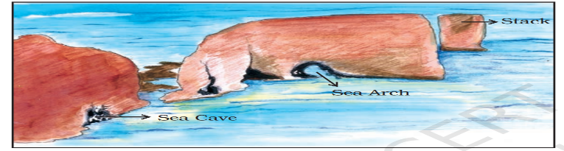  1.Identify which features are given in the above picture.  Features made by sea waves  2.Explain the feature ‘sea arches’?  When cavities of the caves become bigger and bigger and only the roof of the caves remain, such a feature is called as sea arches. | 2 Marks
13 | Read the following paragraph and answer the following questions: -  Human beings interact with the environment and modify it according to their need. Early humans adapted themselves to the natural surroundings. They led a simple life and fulfilled their requirements from the nature around them. With time needs grew and became more varied. Humans learn new ways to use and change environment. They learn to grow crops, domesticate animals and lead a settled life. The wheel was invented, surplus food was produced, barter system emerged, trade started and commerce developed. Industrial revolution enabled large scale production. Transportation became faster. Information revolution made communication easier and speedy across the world.  1.What is barter system?  It is a trade in which goods are exchange without the use of money.  2. What made communication easy and faster across the world?  Information revolution made communication easier and speedy across the world. | 2 Marks
XVII | Answer in detail: - | 9 MARKS
14 | Explain with examples the different components of Environment.  - Major Components of environment are – Natural, Human-made and Human beings.  - Natural Components: Land (Lithosphere). Water (Hydrosphere). Air (Atmosphere). Living things (Biosphere).  - Human-made Components: Buildings, parks, bridges, roads and monuments.  Human Components: Individual, family, community, religion and economic. | 3 Marks
15 | Draw a neat and labelled diagram of a volcano.  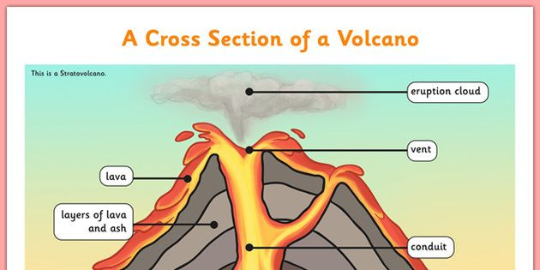 | 3 Marks
16 | Draw and label the diagram of ‘Rock Cycle’  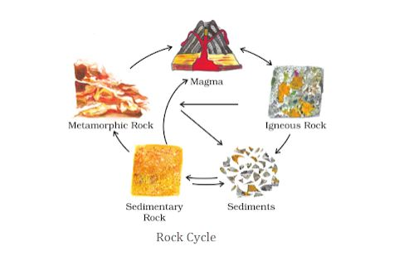 | 3 Marks

